How dangerous is to fly?
You have to admit that you asked yourself at least once in your life – “What is the chance that this plane will crash?” when you step aboard the plane that will transport you to your next vacation destination. Does it matter where or when you fly? What is the chance that this is the last plane you take?
Let’s take a look at the map of plane crashes where plane was completely destroyed. Data provided by Aviation Safety Network and includes all kind of planes.
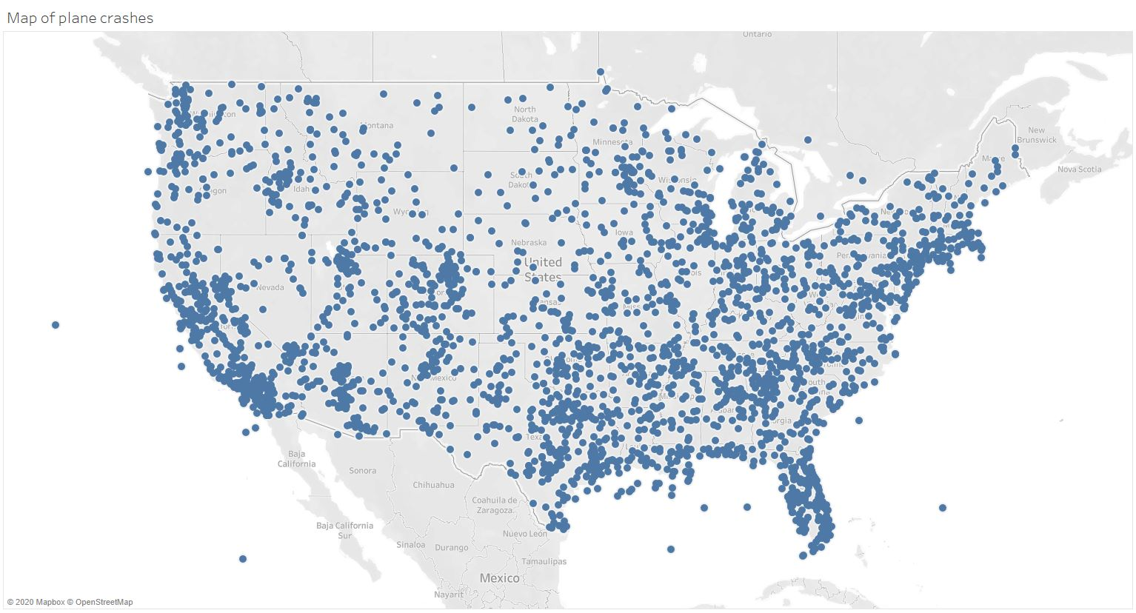
First of all – don’t panic. Map represents vast amount of data, starting with crash in 1974 and ending latest info of April 2020. There are 3372 crashes where plane was destroyed in the US. As we can see on the map it can happen pretty much anywhere. Lest take a look at state statistics.
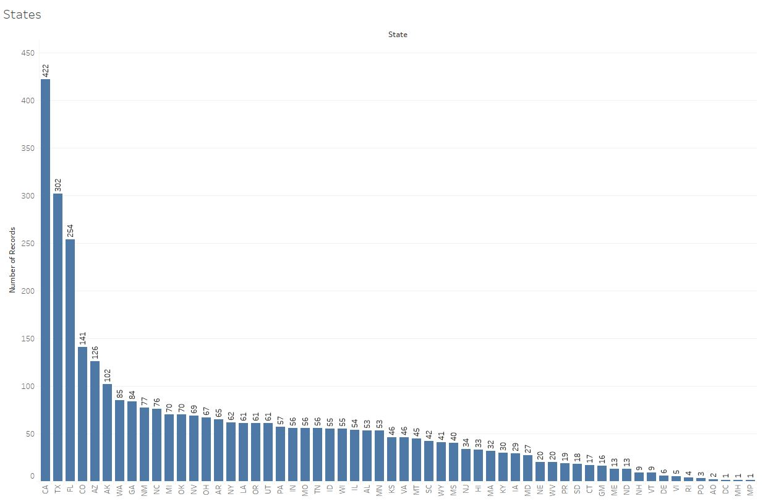
California is a “Leader” with 422 plane crashes followed by Texas (302 crashes) and Florida (254 crashes).
California is the most populated state with 39,937,489 peoples and 256 density (p/mi²) and keeping in mind that it is also richest (and poorest) state, it makes sense that more people can afford small private jets. You have money to buy a jet, you have enough space to store it and you have a relatively good weather all year to fly.
If we will take a look at the plane manufacturers we will see similar trend – the more planes you deliver, the more crashes you will have.
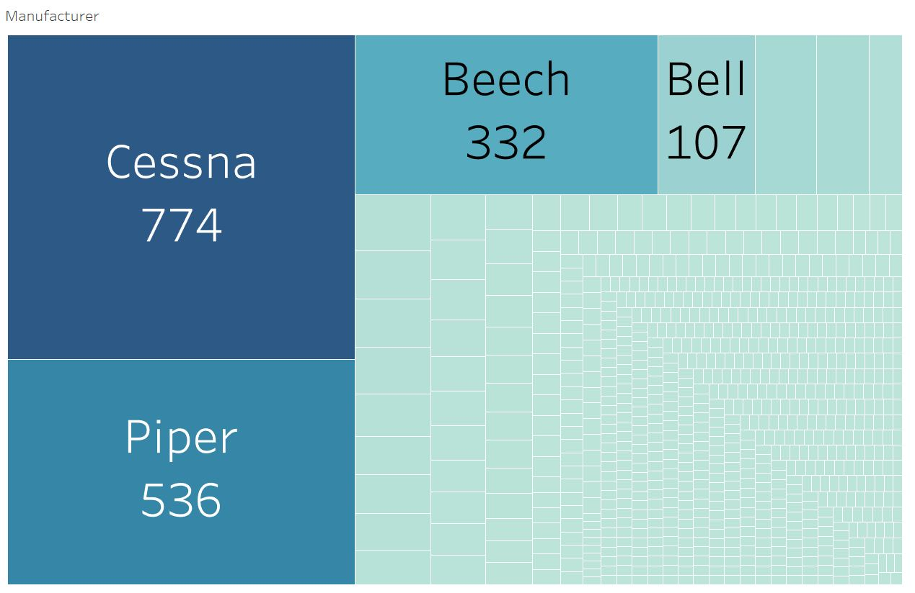
Most of the crashed planes belong to three companies: Cessna, Piper and Beech. But they are the biggest manufacturers where Cessna itself is the highest-volume producer of general aviation aircraft in the world. In 1975 Cessna already produced its 100,000th single-engine airplane.
If we assume that by now this number is doubled than we have a 0.38% of all Cessna planes have crashed. It seems a lot but we cannot rely on this number. The probability of an airplane crashing depends on several factors, such as the type of airplane, the conditions in which it is operated, the route flown, the airports used, the experience of the flight crew, and many other factors that are not related to manufacturer. For example, the largest airline in the world – American Airlines, had only one accident in past 10 years where 20 people suffered minor injuries. Considering that American Airlines offered around 24,455,000 different flights for 10 years – It is safe.
All that means is that chance that your plane will crash is so small that you shouldn’t even worry about it and it is better to keep your attention driving safe every day from work. Because in 2015, there were 32,166 fatal motor vehicle accidents that lead to just over 35,000 deaths. In pure statistical terms, it’s more dangerous to drive a car than to fly on a plane.
So don’t worry, enjoy your flight and be safe.

